Binod Bihari Mahto Koyalanchal Universf, Dhanbad
202 0

SYLLAB FOR
MASTE SCI CE I BOTANY CH ICE BASE CREDIT SYSTE

ACAD I ESSIO
w.e.f. 202#-2022

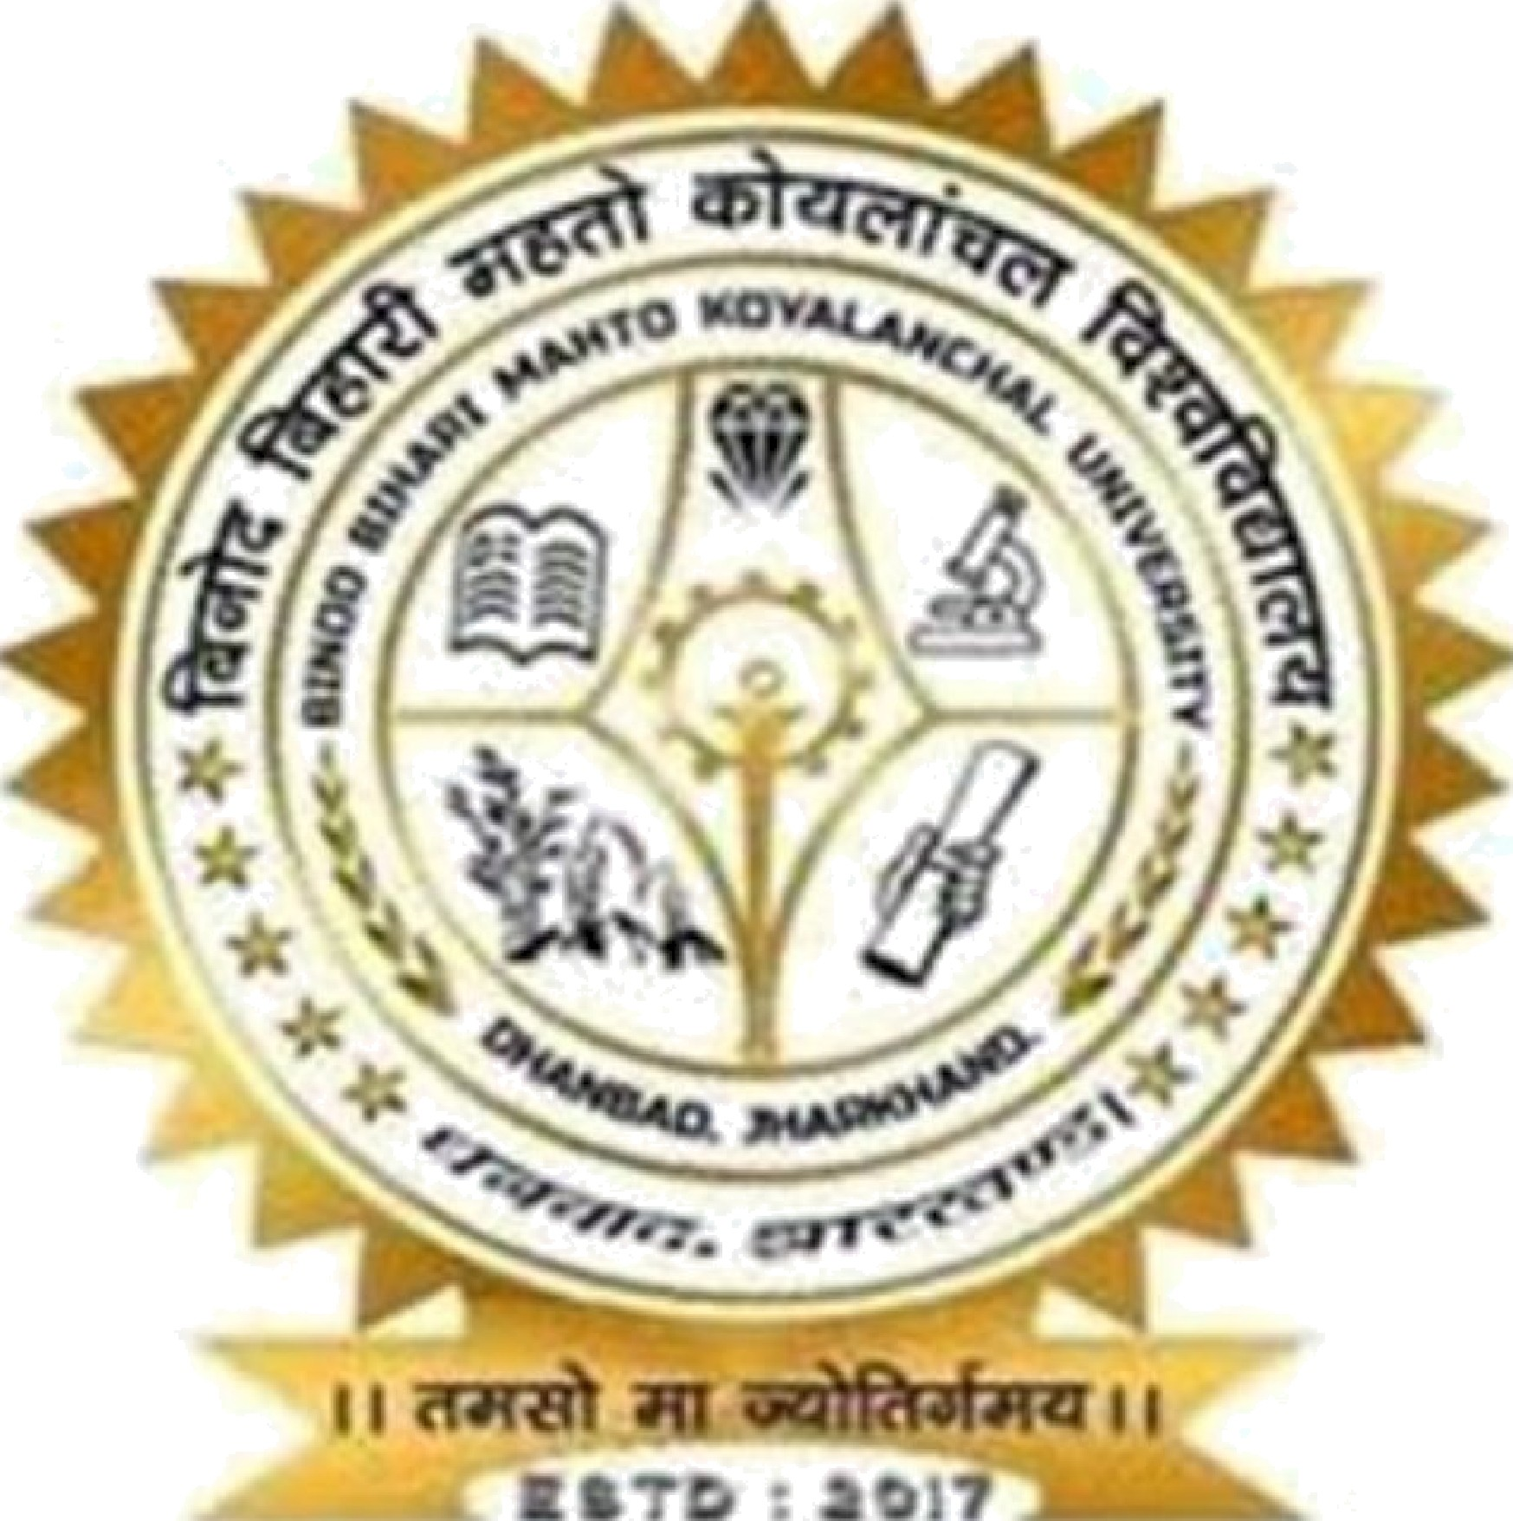

HARI MAHTO KOYALANCHAL RSITY,
DHANBAD

Page

Members of Board of studies of CBCS under Post-Graduate Syllabus as per Guidelines of the Binod Bihari Mahto Koyalanchal University, Dhanbad.

S.No

MEMBERS DESIGNATION

SI G NATURE

- CHAIRMAN DR. KALPANA PRASAD ASSOCIATE PROFESSOR,
HEAD,
UNIVERSITY DEPARTMENT
OF BOTANY,
BBMKU, DHANBAD.

- EXTERNAL EXPERT
MEMBERS

MEMBERS

PROF. ANWAR MALLICK

PROF. KUNOOL KANDIR

DR. J. N. SINGH
PRO? FESSOR, VINOBA BHAVE UNIVERSITY (BOTANY)

PROFESSOR, RANCHI UNIVERSITY (BOTANY)

ASSOCIATE PRO? FESSOR, PRINCIPAL
R. S. P. C?LLEGE,

DHANBAD
Binod Bihari Mañto Hoyalancñal Universt¿7, Dñanbad
2020

- INVITED MEMBERS Dr. SANJAY KUMAR ASSOCIATE PRCE FESSOR
SINHA S.K.M.U
(BOTANY)

Page | 2

Thank you for using www.freepdfconvert.com service!

Only two pages are converted. Please Sign Up to convert all pages. https://www.freepdfconvert.com/membership

